REVIEW OF THE HISTORY AND THE CONTENTS OF THE APOCRYPHA
David B. Brooks
David.b.brooks34@gmail.com
Draft of 16June2020-Essay Version
6,920 words including introductory materials

Abbreviations
CE = Current era, which is identical to the more common AD
BCE = Before current era, which is identical to the more common BC
Book = Any collection of pages of text on paper, vellum or papyrus with several sections
Chapter = Any one of the sections within a book

Presentation in five parts:
- Table of Contents of The Apocrypha
- Overview by DBB of the history and contents of The Apocrypha, based on the “American Translation” by Edgar J. Goodspeed, a New Testament scholar based at the University of Chicago, originally published in 1938
- Selected examples of art and illustrations from The Apocrypha
- Comments on the chapter of The Apocrypha entitled “The Additions to the Book of Esther,” which is mentioned briefly in part 2.

The first, second, and third parts follow below. The fourth part is a separate document that will probably be presented later in the year, close to Purim, which is of course its focus

Acknowledgements
Several people helped me with preparation of these documents. Most important was Dr Caroline Pestieau, my former colleague at Canada’s International Development Research Centre, who had a strong Catholic education and helped me explore initial and later Catholic attitudes and activities related to The Apocrypha. Rabbi Elizabeth Bolton of Synagogue Or HaNeshamah in Ottawa worked with me on The Additions to the Book of Esther. Rabbi Emeritus Reuven Bulka of Congregation Machzikei Hadas in Ottawa and Rabbi Deborah Zuker of Kehillat Beth Israel, also in Ottawa, both took time to tell me of the role that The Apocrypha had played in their education and experience.
I am also grateful to the ten or a dozen congregants of Adath Shalom in Ottawa who sent me comments or excerpts of materials concerning The Apocrypha, some of which now appear in this text.

THE APOCRYPHA
CONTENTS*
- The First Book of Esdras
- The Second Book of Esdras
- The Book of Tobit
- The Book of Judith
- The Additions to the Book of Esther
- The Wisdom of Solomon
- Ecclesiasticus or the Wisdom of Jeshua the Son of Sirach
- The Book of Baruch
- The Story of Susanna**
- The Song of the Three Children**
- The Story of Bel and the Dragon**
- The Prayer of Manasseh
- The First Book of Maccabees
- The Second Book of Maccabees

*Edgar J. Goodspeed (1938), The Apocrypha: An American Translation, New York: Vintage Books/Random House, page xi.
** In some versions these three chapters are grouped into one book entitled The Additions to Daniel

THE APOCRYPHA
REVIEW OF ITS HISTORY AND CONTENTS

David B. Brooks
david.b.brooks34@gmail.com

- It is only an approximation to say that the book that we call The Apocrypha appeared between the Hebrew Bible and the Christian Bible, which is to say in the two centuries BCE. However, adjustments to the HEBREW BIBLE were still being made at the time of the Mishnah in the 2nd and 3rd century CE. (There never was a formal canonization process for our Bible, but by the 4th century it was in the form that we know today.) The 14 chapters that make up The Apocrypha, and that were subsequently integrated into the CB, were probably written late in BCE in Hebrew or Aramaic but first published in Greek, which was the intellectual lingua franca of the time. For example, The Book of Tobit was formerly thought to have been written in Greek, but the Dead Sea Scrolls revealed several Aramaic and Hebrew manuscripts. It is now accepted by most scholars that all chapters of The Apocrypha originated in Hebrew or Aramaic, with some of them being edited either in Greek or later in Latin.

- What we now know as a book entitled The Apocrypha originally appeared as a collection of 14 additional chapters that were added to the Septuagint, the Greek-language version of the Hebrew Bible, very early in the new millennium. We know very little about how or why or by whom they were collected and selected for the Septuagint. We have no evidence even to suggest that those 14 chapters were ever read by the men of The Great Synagogue, much less considered any other rabbinic group that was active at that time. The seashore of Athens was separated from the hills of Jerusalem by more than the Philistines. As shown in Christine Hayes’ superb book, What’s Divine about Divine Law? (2015), whose work I describe further below, those two cities were developing very different views of the nature of divinity.

- What I have learned from a well-educated Catholic is that in 382 CE a scholar named Jerome—the man who is now generally called Saint Jerome--became Pope Damasus' secretary, which was a senior position in church hierarchy. Evidently, he was highly bothered by the fact that many conflicting translations of their Bible were circulating at that time, and different churches were using different and sometimes conflicting versions. He therefore proposed undertaking a whole new translation of the Greek Septuagint as well as the several gospels and other church literature into the then-increasingly common Catholic theologi-cal language of Latin. For the next 20 years, 390 to 410 CE, Jerome was based in Jerusalem learning Hebrew and correcting the Septuagint from Hebrew manuscripts before putting it into Latin in a book called the “Vulgate.” During the fifth century, the Vulgate became the only authorized/ canonical bible for Roman Catholics until the Church authorized new translations from Hebrew and Greek in the last century. Unlike the Roman Catholic Church, Greek Orthodox and Russian Orthodox Churches continue to use the Septuagint, as do the Coptic and Maronite Catholic Churches. In Paragraph 9 below, I will describe what Protestant churches did with The Apocrypha a millennium later.

- At some point in the long process of translation, Jerome recognized that those 14 chapters did not appear in what was by then the final version of the Hebrew Bible. Here too, Jerome knew that, given the diversity among Catholic churches at that time, some of the added chapters from the Septuagint were already being widely used, but others were not. Therefore, he did not want to exclude any from the Vulgate. Then, for some reason, he also put the same 14 chapters into a separate book, and, for want of a more religious name, called it The Apocrypha with both the T and the A capitalized—in, effect, “Those that Were Hidden”--and that title has remained unique ever since--for the next 1500 years! In making that second volume, Jerome also adjusted some titles. For example, the name Esdras, which is Greco-Latin for Ezra, was expected to following the two books of Ezra in the Hebrew Bible. (It was a few hundred years before it was common to rename the Second Book of Ezra as Nehemiah.) Therefore, what were Esdras 3 and 4 in the Septuagint became Esdras 1 and 2 in the Vugate.

- What are called “books” in The Apocrypha are more conveniently described as chapters. They consist of two chapters of Esdras and two of Maccabees, and three that in some editions are brought together as Additions to Daniel, plus another seven chapters. Of course, publication in this or that format, or even canonization, did not stop Jews from writing. As I shall explain shortly, other works written at roughly the same time are called “apocryphal,” which literally means “hidden,” and which are spelled with a lower case “a.” They used to carry a flavour of heresy, especially by Catholic theologians, but they no longer do. The important point is that, aside from the Hebrew Bible itself, The Apocrypha stands out among all the other works written BCE and deserve our attention.

- Having written that previous sentence, I must admit that, with one exception, The Apocrypha has all but disappeared from modern Jewish bibliographies. That exception is The First Book of Maccabees, which tells us much of what we know about that period of Jewish history and the post-Biblical holiday of Chanukah. I’ll come back to that chapter later. However, to establish this point, one retired rabbi told me that The Apocrypha had played no role at all in his rabbinic studies, and that it was only after reading The First Book of Maccabees that he under-stood why Chanukah lasts eight days. (It was originally a replacement for the holiday of Sukkot that had been missed when the Seleucid Greeks were in command of the Temple.) Another rabbi mentioned that apocryphal works served as general background for much in their rabbinic training but not as specific books to study.

- As indicated above, numerous other books or stories or religious texts did not make it into the Septuagint, and therefore not into The Apocrypha. Those other books were presumably seen as too dramatic or too superficial or perhaps just too late. Many, including the Third and Fourth book of Maccabees, were gathered into another collection called Pseudepigrapha, which means that, to gain credibility they were attributed to false authors, typically various biblical patriarchs and prophets. However, if Jews considered The Apocrypha as secondary to the Hebrew Bible, the Pseudepigrapha was a distant third among all those works written before the Talmud. Though modern scholars, both Jewish and Christian are generally aware of The Apocrypha and may have read some of it, only The First Book of Maccabees has attracted much interest from the Jewish community—though few enough of them know of its true origin. In short, apart from the Hebrew Bible itself, The Apocrypha stands out among all other works written BCE as deserving more attention than it has received for many years by Jewish individuals and both lay and scholarly groups.

- Though the contents of The Apocrypha were never part of the Hebrew Bible, they were inserted into and remain in Catholic Bibles to this day, though not as a single package. More typically they are scattered among other chapters, just as they were in the Septuagint. The important point is that they are considered equally as holy / canonical as other parts of what is commonly called the Old Testament. Indeed, they were reconfirmed as canonical by the Council of Trent in the mid-16th century, which significantly was the time of the Protestant Reformation, which is discussed next.

- Things were very different for the Protestant Reformers and their Bibles. Starting from William Tyndale who was executed in 1536 for translating the Bible into English and printing it with a press, English language versions became common at least from the early-1600s CE. (An English language version for Roman Catholics became available after 1582.) At first all 14 chapters were still found in Luther’s German language Bible (1534 CE) in a special “intertestamental” section, and in the English language Kings James version first published in 1611. Just one century later during the English Civil War (1642-1651), the Protestant Westminster Confession English language Bible excluded them entirely from its canon. From then on, some or all chapters were excised from Protestant Bibles under Puritan influences until none or almost none were left. Yet all chapters remained in the King James Bible until they were removed in 1885.

- In recent years some chapters have begun to reappear in the latest English language Protestant Bibles. Beyond Puritan views, arguments for and against inclusion of The Apocrypha varied widely. Some said that it was not divine and was not in the “Old Testament,” so should not have been included in the first place. They were opposed by others who argued that text that was considered part of the Bible for nearly 2,000 years should not be changed. And, with an argument that sounds distinctly modern, a few people claimed that The Apocrypha wasn't removed by the church but by printers to cut costs in distributing Bibles in the United States. More importantly, the contents of The Apocrypha were recognized by most religious scholars as texts with useful materials—witness, R. H. Charles’ 2-volume The Apocrypha and Pseudepigrapha of the Old Testament, which have been described as “arguably the most important non-biblical documents for the historical and cultural background studies of popular religion in New Testament times.” The words “historical and cultural” represent an implicit qualification to caution readers that those works are not relevant for doctrinal issues.

- However used, the influence of The Apocrypha gradually declined as indicated by the fact that, though there were English language versions since at least the “Great Bible” of 1535, it was 1938 before a translation into modern English was published by Edgar Goodspeed, a theologian and New Testament scholar at the University of Chicago. It is to his credit that his 1938 translation was the first in many centuries to go back to the Greek original instead of the 4th century translation by Jerome into Latin (the Vulgate).

- At least as important for many scholars, some chapters in The Apocrypha exhibit stylistic characteristics, use wording, or focus on apocalypses typical of what appears in Christian Bibles and late BCE Judeo-Christian writing. The 1st Book of Esdras gets off either naively or maliciously in verse 1:3 by describing Levites as Temple Slaves. That may be a mistranslation as the Hebrew words for slave and servant are the same. Christian insertions in the 2nd Book of Esdras are more definite, as with references to a Son of God (2:47; capitalization in original) and original sin (1:32; 3.21; 16:64) that are essential to Catholicism but foreign to most if not all Jewish thought. Less surely, whole paragraphs may have been Christian insertions. These elements led some scholars to propose that The Apocrypha is a link between the Hebrew Bible and the Vulgate. Catholic Bible. Goodspeed’s introduction to II Esdras is more cautious (pp. 39-40): “Even the portions of II Esdras that are not obviously Christian may well have been affected by Christian doctrine.” Thus, in his introduction to the book, Goodspeed refers to it as “this appendix to the Old Testament” and says that it is “indispensable to the student of the New Testament, of which it forms the prelude and background” (page x). Today’s scholars tend to be cautious about any such statement. Certainly, I am more comfortable with Goodspeed’s later comment that Alexander the Great was a catalyst for far-reaching changes in the world. Before his conquests, the world was characterized by “the ideal, the heroic, the general”; afterwards by “the bourgeois, the actual, the individual (xiii).”

- If the contents of The Apocrypha, and before it the Septuagint, was to serve as a link between cultures, one might expect it to be between Jewish rabbinic law and Hellenistic natural law, both of which were flourishing in the last couple of centuries BCE. The sharp contrast between them has been explored in depth by Professor Christine Hayes in her book, What’s Divine about Divine Law? Early Perspectives. A synopsis by the publisher gives a good summary:

In the thousand years before the rise of Islam, two radically diverse conceptions of what it means to say that a law is divine confronted one another with a force that reverberates to the present. . . . Christine Hayes shows that for the ancient Greeks, divine law was divine by virtue of its inherent qualities of intrinsic rationality, truth, universality, and immutability, while for the biblical authors, divine law was divine because it was grounded in revelation with no presumption of rationality, conformity to truth, universality, or immutability. . . . Second Temple and Hellenistic Jewish writers, from the author of 1 Enoch to Philo of Alexandria, were engaged in a common project of bridging the gulf between classical and biblical notions of divine law, while Paul, in his letters to the early Christian church, sought to widen it. Hayes then delves into . . . classical rabbinic Judaism to reveal how the Talmudic rabbis took a third and scandal-ous path, insisting on a construction of divine law intentionally at odds with the Greco-Roman and Pauline conceptions that would come to dominate the Christianized West.
Whatever the value of Hayes’ conclusions, I looked for but found no explicit suggestion of any attempt in the chapters of The Apocrypha to make a bridge between Hellenism and rabbinic Judaism. More accurately, I found no such evidence other than what might have been expected in, for example, wisdom literature that were not already present in Jewish literature. Goodspeed cites the chapter entitled The Wisdom of Solomon as a good example of the fusion of Hebrew and Greek ideas with the former dominating prior to Chapter 11), and the latter thereafter (177). However, he does not seem to be referring to ideas related to alternative concepts of divinity but rather to style and to concern about materialism and idolatry, which are also concerns in the Hebrew Bible.. In summary, far from seeing a link between Hellenistic and rabbinic thought, it is more likely that the Hebrew or Aramaic authors of what first appeared in the Septuagint were quite unaware of Greek philosophy, and, further, that it was not until after Philo of Alexandria and Paul of Tarsus worked in opposite ways to deal with the gap that it became evident how wide it really was.

- The character of chapters in The Apocrypha ranges from romantic short stories in a Hellenistic style (eg, Judith), through Biblical scripture showing that good things come to good people (eg, Tobit), and examples of Biblical prayers (eg, Manasseh) and prophecy (eg, The Book of Baruch). Spicing the whole book is a short story (Susannah) that illustrates the proper application of Biblical law on capital punishment for sex crimes, and some fine examples of wisdom literature. The Wisdom of Solomon is notable for its fusion of Hebrew and Greek ideas with Hebrew dominating in early portions and Greek thereafter. Also notable is Ecclesiasticus, or the Wisdom of Jeshua son of Sirach (not to be confused with Ecclesiastes from the Hebrew Bible), which is written by a man who uniquely in The Apocrypha makes no secret of his name. It is no surprise that Goodspeed says that, “The Apocrypha is rather a library than a single book” (x).

- Turning to some assessment, the chapters in The Apocrypha may be as diverse as those in the Hebrew Bible, but in general they do not measure up to either its literary or its religious quality, nor is there much linking from one chapter to the next, except in the two pairs. Frankly, I find many of the chapters, including both I and II Esdras (including the Tale of the Three Guardsmen), Baruch, and a few others just boring. (Apart from that Tale, the two books of Esdras do little more than summarize Chronicles, Ezra and Nehemiah.) However, I can illustrate the quality problem more clearly by reviewing the three chapters that are commonly grouped together under the title of The Additions to Daniel. To start, note that the name “Daniel” is not mentioned in one of the three chapters, and there is no clear link between the man named Daniel in the other two chapters and the Daniel of the Hebrew Bible, except for their refusal to bow down to the gods worshipped by Nebuchadnezzar, who was the powerful and long-lived king of Babylon in the 5th and 6th century BCE. He is a convenient person to select if one needs a villain in a Jewish story that takes place before the new era.

  - In the chapter where Daniel plays no role, we meet Azariah, who one of was Daniel’s companion in the furnace (Daniel 1-3). He is said to be author of the prayer in the chapter appropriately entitled “The Song of the Three Children,” which refers to the three young men who were also with Daniel in that furnace and who had followed his example in refusing to bow down to idols. The Song is partly a complaint to God about why He let them be put into that furnace and partly a standard blessing of God. At the end, the prayer shifts to an antiphonal passage that I find hard to think of singing when threatened by a painful death.

  - Another of the three chapters is entitled The Story of Bel and the Dragon. Bel is an idol, and the Dragon is a huge serpent kept by Cyprus, king of Persia. Daniel is a companion of the king, and he sets out to destroy these two false gods. First. Daniel shows the king that it is his priests and their families who are eating the food and wine set aside for the idol. After that, Daniel feeds the serpent some stew containing a lot of tar, which causes its stomach to burst. Unfortunately for Daniel, so far from being pleased, the king, the priests, and other courtiers sentence Daniel to be put in the lion’s den, which might seem to be a link to Chapter 6 of Daniel in the Hebrew Bible but involves a different time and place. The one link is Daniel’s refusal to bow down to a false god. Whatever may have been intended by its author, this story is more in the style of a fairy story than anything else that appears in either the Hebrew or the Christian Bible.

  - The most fun of the three additions to Daniel is entitled The Story of Susanna, and a fine romantic short story it is, said to be typical of Hellenistic literature. Briefly Susanna is the faithful and pious wife of a wealthy man who owns a villa. Without any servant beside her, she takes her bath in the garden, far from public view. One day two lustful bad guys, described as elders in some editions, conceal themselves in the garden, surprise her when she is naked, and demand sex from her. When she refuses, they rush outside, claim they found her with a man, who of course escaped, and accuse her of adultery, which is punishable by death. For whatever reason, the two men are believed, and, despite the weeping of servants and family, she is taken to be executed. At the last moment (1:45), “God stirred up the holy spirit of a young man named Daniel,” and he interrupts the proceedings and reminds everyone—Why the elders did not know is not explained!—that capital punishment requires not just two witnesses but two independent witnesses. When the two bad guys are questioned separately, their stories differ, and it is they who are executed. Susanna is freed of the charge. As the text goes (1:64), she “had done nothing immodest. And from that day onward, Daniel had a great reputation in the eyes of the people.” It only remains to be said that the Hebrew Bible, which prides itself as being a source of divinely inspired law, does not need a short story to illustrate how carefully any charge that leads to capital punishment must be investigated.

- A few of the 14 chapters in The Apocrypha do stand out from the others. The three that stand out in my mind are The Book of Tobit, The Book of Judith, and Ecclesiasticus, or the Wisdom of Jeshua son of Sirach.

  - Ecclesiasticus is a notable example of wisdom literature with a carefully balanced perspective between other-worldly and this-worldly advice. For example (38:1-4): “Show the physician due honor in view of your need of him, / For the Lord has created him; / Healing comes from the Most High, / and he will receive presents from the king. / The skill of the physician exalts him, / And he is admired among the great. / The Lord has created medicines out of the earth, / And a sensible man will not refuse them.” Perhaps because we know the name of the author of Ecclesiasticus, Goodspeed is more inclined to express his own opinion about this chapter in The Apocrypha. In his introduction to the chapter (221), he writes that the text, “presents the reflections of a learned and experienced man who is conscious of his own attainments. He is aware of the law of the Most High . . . but his emphasis is on the worldly wisdom that comes from experience. . . . His code is enlightened self-interest.” All of that is no doubt true, but must be balanced against the man’s many pretentious statements and an amazing misogyny that is extended to most women and relaxed only for women’s role as mothers.

- If I were forced to select just one chapter from The Apocrypha, it would be Tobit. More than any other chapter, perhaps other than Susanna, Tobit is a pleasure to read. Goodspeed’s abstract is an excellent review: “Tobit combines pre-existing novella motifs into an edifying romance. Characterization and plot construction are effective, and the piety genuine and moving. The emergence of individuality and of personal religion . . . are characteristic phenomena of the Hellenistic age.” (Please excuse me for saying that, had pre-existing motifs been forbidden when the Hebrew Bible was put together, it would have been much shorter.) A summary of the story of Tobit appears in an essay by Michael Kiel in Oxford Bibliographies: “The Book of Tobit tells the story of Tobit and his family, who are living as exiles from Israel after the Assyrian conquest. Through a series of events, Tobit goes blind and sends his son on a journey accompanied by the angel Raphael disguised as a human. On his journey, the son Tobias meets Sarah, who is afflicted by a demon. Raphael intervenes and dispatches the demon. They return to Tobit and his wife, Anna. Tobit’s sight returns, and he dies old and happy because of God’s intervention in their travails. The book is not historical, but rather a folk tale with manifold entertaining elements, such as defecating birds, meddling fish, menacing demons, and disguised angels. Beneath the surface, however, the book interacts with deep theological questions at the core of the human condition, questions that also find expression—with various answers—throughout the Jewish scriptures: Where does suffering come from? What are the benefits of righteousness? What is the value of religious tradition? In answering such questions through its entertaining narrative, the Book of Tobit weaves together an erudite panoply of religious, scriptural, and cultural traditions.”

- The Book of Judith, more than a short story, almost a novella, is a real treat. If I promoted Tobit with an analysis of the chapter, I will now do so for Judith by retelling the contents. The first third of Judith has nothing at all to do with Judith, but is a long description of how Nebuchadnezzar, King of Assyria and “lord of all the earth,” (2:5; 6:4) together with Holofernes, general of his army, plans to subjugate all the nations west of the Euphrates River. As the story opens, their record of success is impressive, with community after community falling before them in “fear and horror.” His army also imposed Nebuchadnezzar’s gods on the subjugated peoples. However, the Israelites “had prepared for war and had closed the passes of the mountains and fortified every mountain top and put barricades in the level country,” (5:1) as well as initiating prayers and fasting and sacrifices for the non-combatants. For some reason, this preparation made Holofernes angry. (I can’t imagine what else he expected.) He then asked, “What god is there except Nebuchadnezzar,” (6:2) and swore vengeance against Bethulia, which was the nearest Israelite city to the Assyrian encampment.

- Bethulia is feeling quite sure of itself because the mountain geography is its main defense. Holofernes outsmarts them by seizing control of the spring upon which Bethulians depended for their water. (If I asked just above “what did Holofernes expect,” I now ask the same of the Israelites. Capturing water sources was by means a novel military tactic.) Despite the urging of the leaders to hold out, most people were prepared to surrender. At last, enters Judith, a well-borne woman who was the widow of a wealthy landowner for more than three years prior to the siege. She is described as wealthy, beautiful, and pious (8:8). “There was no one who spoke ill of her, for she feared God with all her heart.” She too tried urgently to convince the community not to surrender to the Assyrians but to retain their faith in God for His ultimate deliverance. Despite their respect for Judith, her words were in vain, and the leaders said that they would surrender in five days. At that point Judith took things into her own hands. She prays fervently to God—she is not naïve about what happens to women after military defeat or surrender—and emphasizes that she will need God’s help in order to carry out her plan.

- Now the real excitement begins. At the entrance of the Assyrian camp she says that she is a Hebrew who is disappointed with her people and has escaped from the city in order to tell Holofernes about a secret route for his army to reach the city. She then beguiles him with her entirely false opinions of the greatness of King Nebuchadnezzar, but, presumably to instill confidence in her actions, Judith will not eat with Holofernes and insists that she needs to spend three days praying for the souls of the Israelites who are about to be killed. Holofernes agrees and orders that she be protected. At the end of those three days, and with his eye on her body, he invites her to a banquet, which, just as at Passover, is eaten reclining. This time, she agrees to eat and drink and even to lie down with him. (The wording here is ambiguous but, whether this is deliberate or not, I have no idea. One would need to read Greek in order to determine whether it was or was not sexual.) Holofernes is “delighted with her,” and “he drank a very great deal of wine, more than he had ever drunk in one day since he was born” (12:20). Everyone else leaves the banquet hall, and the door to Holofernes’ bedroom is closed with Judith inside. She waits until he is “prostrate on his bed,” prays to God for help, takes his scimitar, and with two blows and “all her might” (13:8) cuts off his head. Judith puts the head into her food bag, leaves the Assyrian camp, and takes a deliberately circuitous route to Bethulia.

- The remainder of the story follows an expected course. The men of Bethulia give thanks to God and, in preparation for an Assyrian attack, hang Holofernes’ head on the city wall. When Assyrian soldiers see his head, they flee, and their camp is plundered. At that point, Judith emulates Deborah with a victory song to God, and spends the rest of her long life as a pious widow. The book closes with (16:25): “No one could terrify the Israelites in Judith’s days, nor for a long time after she died.”

- I conclude my review of the remarkable Book of Judith with two final points. First, the text tells us that Judith lived to be 105 years old, and, despite many suiters, never married again. Other than Abraham’s wife Sarah, I can think of no woman in the Hebrew Bible whose death is so specifically noted. Second, I said above that Judith was emulating Deborah with her song, but that sequence depends upon the assumption that Nebuchadnezzar was the bad king of the story rather that someone much earlier in Israelite history. In many ways, it does seem that Judith’s victory song (16:2-17) might come first after all except those of Moses and Miriam after the Israelites cross the Reed Sea. It opens with the words, “Begin to play unto my God with tambourines, Sing unto my Lord to the sound of cymbals” and shortly thereafter are the significant words, “The Lord Almighty brought them to naught, By the hand of a woman.” (Italics added.)

- I also identified several chapters in The Apocrypha that I felt should be firmly rejected from any comparisons with the Hebrew Bible. The two chapters of Esdras have already been discussed, but two more need to be reviewed more carefully.

- My strongest adverse reaction was to The Additions to the Book of Esther, which Goodspeed dates as being written in the first century BCE. Given that the holiness—that is, the divine origin--of Esther was still being debated at the time of the Mishnah, he is probably correct, as he is in suggesting that the Additions were written as a reaction against the secular character of Esther and because it is the one book in the Hebrew Bible where the word “God” never appears, at least not explicitly. Given limitations of time, my full adverse review of The Additions must be deferred to a later occasion, perhaps around Purim. Briefly, one cannot change the focus of a story, the timing of events, and the personalities of each of the leading players, and just call it “additions.” I too have problems with the Esther, as in Chapter 9:10 where the sons of Haman are hanged with no reason given other than that are his sons, but that does not give me the rationale for a complete revision of the text.

- I also had a strong adverse reaction to the chapter entitled The Prayer of Manasseh. He was the 14th King of Judah who reigned for about 55 years (698-642 BCE). Unhappily, he is best remembered for re-instituting polytheistic worship and for reversing the monotheistic practices instituted by his father, King Hezekiah, one if the most pious of the Judean kings. Not surprisingly, Manasseh is condemned in the Hebrew Bible (among other places 2nd Kings 21:2). From a legal perspective, it is a fundamental principle of Judaism that forgiveness only comes after repentance, as for example in Chronicles II (33:21-25) where God says, “It is not thy sin, but thy impenitence, that bars heaven against thee.” I have read and reread Manasseh’s words, and I find little to suggest that he even thought about repenting his idolatry. If anything, the prayer in The Apocrypha sounds boastful about his sins. Had the prayer been anonymous, I might have taken it as a naïve, if likely ineffective, plea, but, coming from Manasseh, it would be a totally inappropriate addition to the Bible.

- If The Apocrypha declined in theological influence over the centuries, it never lost its influence in the visual fine arts or among many illustrators. Judith and Susanna in particular attracted a lot of painters, some of whom may have had the ironic effect of influencing the Puritans to reject these books from their teachings. Tobit was also a favorite, and likely a less controversial one. However, given the common reluctance of Jewish artists and artisans to create visual forms of art, few of the many images available were originally created by Jews. A very small and totally random sample of both fine art and illustrations appears in an annex to this review.

- In concluding this section of my presentation, I must describe what appears to be an eye-witness account of the Maccabean revolt that provides the historical background we have for our holiday of Chanukah. At the least the First Book of Maccabees does. The Second Book of Maccabees is partly a theological revision of the same story much as Chronicles I and II repeat and revise earlier stories in the Hebrew Bible and partly a history of times before and after the Maccabean uprising. The Second Book also gives us a good idea of the bitterness of the fighting and the corruption promulgated among high-ranking priests—notably by Jason and Menelaus who competed with each other in bribing the king, who at this time was Antiochus Epiphanes, to give one or the other commission of high priesthood. These unpleasant events are described rather more conventionally in the article by Bickerman (see fn 10).

- So much for background. It is intriguing to me that the books were even called The Maccabees, which is of course a reference to Judas, their great military leader at the start of the uprising, but he dies in battle a few years later. The story continues for nearly a hundred years during which time the Hasmonean family has come to rule Judea. Why were the two books not called the First and Second Hasmoneans, which would have been more conventional? I could not find an answer to that question, so I will suggest one of my own. Perhaps the answer is that the Hasmoneans took at least one theologically questionable step. They combined the post of high priest with that of king, two positions that according to the Hebrew Bible’s record of that period in Jewish history were always kept apart—ever since Samuel took the kingship away from Saul for making a sacrifice as if he were a priest (I Samuel 13:1). Of course, at the time of the Maccabean uprising, we now see the Hasmoneans as the heroes. Bickerman (page 80) describes the situation clearly:

The Maccabean movement was primarily a civil war, a religious battle between the orthodox and the reformers. . . . Menelaus was a negative Ezra. Ezra and Nehemiah had isolated the Jews in order to preserve monotheism. Jason and Menelaus abolished monotheism in order to rescue Jewry from isolation. . . . The Maccabees were fighting the Seleucid troops but not Seleucid rule; . . . This was not a national struggle but a conflict within their own camp; ie, a religious war within the Jewish people.
That perspective that the Maccabean revolt was more a civil war between traditionalists and assimilationists within the priesthood than a liberation struggle against the Seleucid Greeks.is now widely accepted.

- I shall conclude my overview of The Apocrypha by quoting from the very end of the book’s 500 pages, which also concludes The Second Book of Maccabees. The words there remind me more of a high school term paper than a major addition to our historical and theological review. However, if they were good enough for a Jewish author in the Second Temple period of Jewish history, they are good enough for me too:

I too will here conclude my account. If it has been well and pointedly written, that is what I wanted; but if it is poor, mediocre work, that was all that I could do.

-/end\-

SELECTED ILLUSTRATIONS TAKEN FROM THE APPOCRYPHA

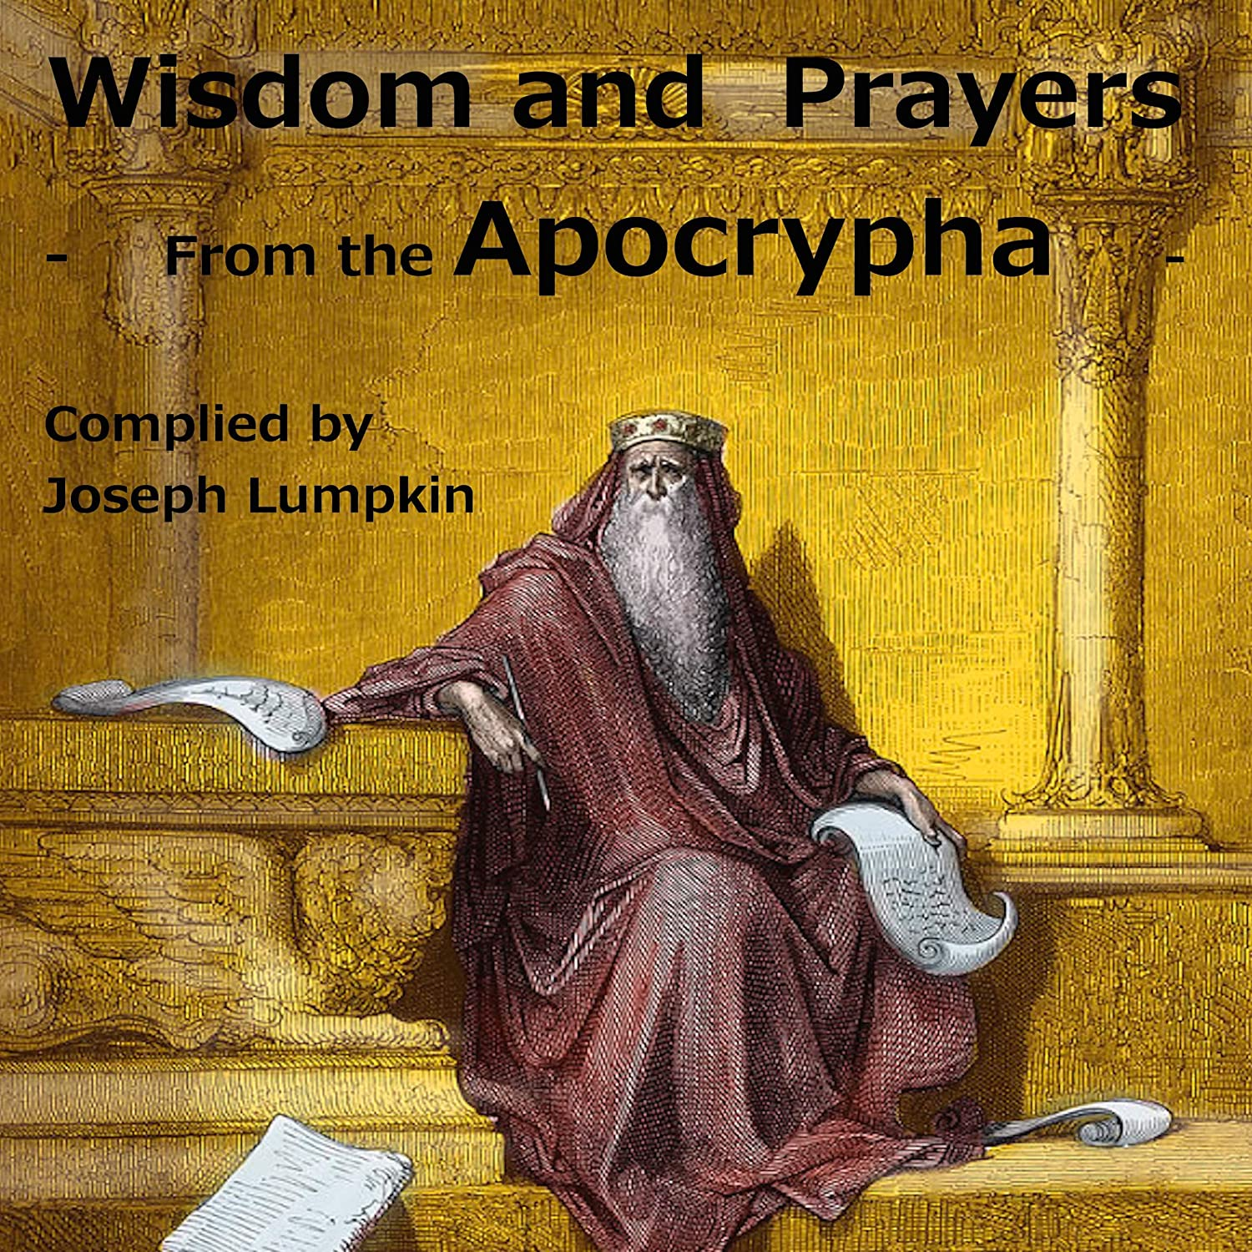

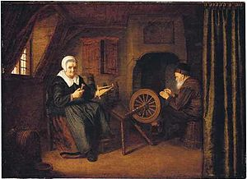
Tobit and Anna by Abraham de Pape c. 1658

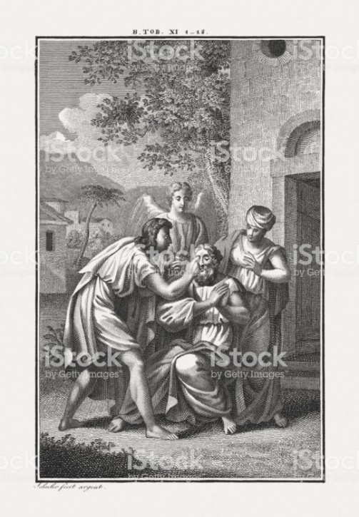
Tobit Curing a Blind Man

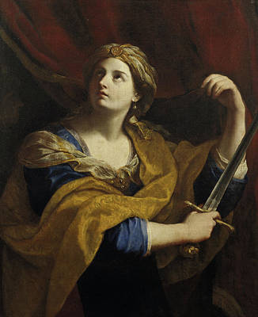
Judith with a sword
Guido Reni
Italy, 1575-1642

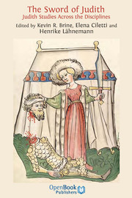
Title Page, 15th Century German Bible
Workshop of Diebold Lauber

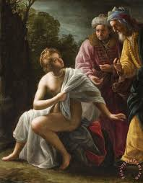
Susanna and the Elders
Jean François de Troy
France (1649-1752)

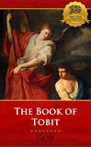

If you wish to have a pdf version of an 1894 version of The Apocrypha, go to: https://www.globalgreyebooks.com/apocrypha-ebook.html
For convenience, I refer to the Vulgate and The Apocrypha as books, but they were likely each produced as a codex. According to Wikipedia: “A codex is a book constructed of a number of sheets of paper, vellum, papyrus, or similar materials. The term is now usually only used to describe manuscript books, with hand-written contents, but describes the format that is now near-universal for printed books in the Western world. The book is usually bound by stacking the pages and fixing one edge to a spine, . . .At least in the Western world, the main alternative to the paged codex format for a long document is the continuous scroll, which was the dominant form of document in the Ancient World. The gradual replacement of the scroll by the codex has been called the most important advance in book making before the invention of the printing press.”
https://www.kingjamesbibleonline.org/Apocrypha-Books/
https://www.logos.com/product/4237/the-apocrypha-and-pseudepigrapha-of-the-old-testament-in-english
One of the morning blessings in most Jewish prayer books begins with the words, “My God, the soul you have given me is pure, You created it, You formed it, You breathed it into me, You watch over it when it is in me.
Christine Hayes (2015), Princeton University Press. A one-hour lecture by Hayes is available at https://youtu.be/4zBRLu_cNtc.
The Encyclopedia Britannica entry on Book of Esdras (2020 online edition) is critical of more than boredom: “The method used in compiling I Esdras is uncertain, especially because of numerous historical inconsistencies and errors; in several instances it also alters biblical texts. . . . Given the historical confusion of I Esdras, many scholars feel that its compiler was more interested in inculcating certain moral and religious ideas than in chronicling Jewish history.”
https://www.oxfordbibliographies.com/view/document/obo-9780195393361/obo-9780195393361-0184.xml
No city with that name is known in Israel. Wikipedia offers the following comment: “The name "Bethulia" in Hebrew can be associated, in an allegorical sense, with "Beth-el" (house of God). It can also be explained as a composite word built from "betulah", virgin, and "Jah", the name of God, so literally "Yhwh's virgin." This suits the portrayal of Judith as a chaste widow and the emphasis on following religious rules, chastity among them.”
For further information on this period, I strongly recommend Elias Bickerman (1970) The Maccabean Uprising: An Interpretation. In Judah Goldin (ed.), The Jewish Expression, 66-86. Even with this independent look, most of Bckerman’s citations are to this chapter in The Apocrypha.

