Adath Shalom Dvar for Oct. 2, 2020
Sukkot & The Sanctity of Time
(Via the lives and writings of Rabbi A.J. Heschel and Rabbi R.J. Adler)
This dvar will be presented in four parts:
First of all, I will describe some of the reasons why we read from specific Torah portions and the Haftorah on Sukkot and also explain the connection to the sanctification of time.
The second part will be an overview of the life and writings of Rabbi Abraham Joshua Heschel.
The third section will be a brief biography, sermon and story from my father, who was inspired by the writings of Rabbi Heschel.
The final section will be a recollection of a personal encounter that we experienced with Rabbi Heschel 55 years ago. I will conclude with a special gift from him.
Sukkot -- Torah and Haftorah readings:
As you know, Sukkot commemorates the 40 years of B’nei Yisrael wandering in the desert, living in temporary structures, tabernacles or booths, on the way to the Promised Land.
Why did the rabbis select the Torah reading for Sukkot to be from Vayikra (Leviticus) 22:26-23:44? Because it contains (in Leviticus 23:34 (EMOR)) -- the primary biblical source for Sukkot: “On the fifteenth day of this seventh month is the Festival of Sukkot, seven days for the L-RD..” The Maftir reading is from Bamidbar (Numbers) 29: 12-16. (Pinchas) describing the specific animal and grain sacrifices to be made on Sukkot.
The Haftorah is from Zachariah (14: 1-21). It was selected because it contains a reference to Sukkot in verse 16: The Haftorah describes Zachariah’s prophesy that some day the other nations of the world will attack Jerusalem and God will intervene. According to Rabbi Hertz, the nations of the world will be converted to the worship of the God of Israel, … Jerusalem would be elevated to the religious centre of the world, a place of pilgrimage for all nations, who will assemble there each year to observe the Feast of Tabernacles.
The Festival of Sukkot begins on the fifth day after Yom Kippur. It is quite a drastic transition, from one of the most solemn holidays in our year to one of the most joyous. Sukkot is commonly referred to in Jewish prayer and literature as Z'man Simchateinu , the Season of our Rejoicing. Z’man in Hebrew is also the word for” time.”
Rabbi Abraham Joshua Heschel (Wikipedia extracts)
Abraham Joshua Heschel (January 11, 1907 – December 23, 1972) was a Polish-born American rabbi and one of the leading Jewish theologians and Jewish philosophers of the 20th century. Heschel, a professor of Jewish mysticism at the Jewish Theological Seminary of America, authored a number of widely read books on Jewish philosophy and was active in the civil rights movement.
After a traditional yeshiva education and studying for Orthodox rabbinical ordination (semicha), Heschel pursued his doctorate at the University of Berlin and rabbinic ordination at the non-denominational, University of Science of Judaism (HWJ) in Berlin.
In late October 1938, when Heschel was living in a rented room in the home of a Jewish family in Frankfurt, he was arrested by the Gestapo and deported to Poland. He spent ten months lecturing on Jewish philosophy and Torah at Warsaw's Institute for Jewish Studies. Six weeks before the German invasion of Poland, Heschel left Warsaw for London with the help of Julian Morgenstern, president of Hebrew Union College, who had been working to obtain visas for Jewish scholars in Europe.
Heschel's sister Esther was killed in a German bombing. His mother was murdered by the Nazis, and two other sisters, Gittel and Devorah, died in Nazi concentration camps. He never returned to Germany, Austria or Poland. He once wrote, "If I should go to Poland or Germany, every stone, every tree would remind me of contempt, hatred, murder, of children killed, of mothers burned alive, of human beings asphyxiated."
Heschel arrived in New York City in March 1940. He served on the faculty of Hebrew Union College (HUC), the main seminary of Reform Judaism, in Cincinnati for five years. In 1946, he took a position at the Jewish Theological Seminary of America (JTS) in New York City, the main seminary of Conservative Judaism. He served as professor of Jewish ethics and Mysticism until his death in 1972.
Heschel married Sylvia Straus, a concert pianist, on December 10, 1946, in Los Angeles. Their daughter, Susannah Heschel, became a Jewish scholar in her own right.
Rabbi Heschel believed that the teachings of the Hebrew prophets were a clarion call for social action in the United States and worked for African Americans' civil rights and against the Vietnam War. Heschel marched in the Selma Civil Rights march with Martin Luther King, Jr. Heschel later wrote, "When I marched in Selma, my feet were praying."
Heschel is a widely read Jewish theologian whose most influential works include: Man Is Not Alone, God in Search of Man, The Sabbath, and The Prophets. At the Vatican Council II, as representative of American Jews, Heschel persuaded the Catholic Church to eliminate or modify passages in its liturgy that demeaned the Jews, or referred to an expected conversion to Christianity. His theological works argued that religious experience is a fundamentally human impulse, not just a Jewish one. He believed that no religious community could claim a monopoly on religious truth. For these and other reasons, Martin Luther King, Jr. called Heschel "a truly great prophet."
The Torah introduced the concept of the holiness of time with the story of creation and the 4th commandment. Remember the Sabbat day and keep it holy.
In his masterpiece, The Sabbath (1951), Rabbi Heschel compares and contrasts space and time in beautiful and powerful language: Here are some quotes:
- Technical civilization is man’s conquest of space. It is a triumph frequently achieved by sacrificing an essential ingredient of existence, namely time. The power we attain in the world of space terminates abruptly at the borderline of time. But time is the heart of existence.
- Judaism is a religion of time aiming at the sanctification of time. Every hour is unique and the only one given at the moment, exclusive and endlessly precious.
- The meaning of Sabbath is to celebrate time rather than space. Six days a week we live under the tyranny of things of space; on the Sabbath we try to become attuned to holiness in time. It is a day on which we are called upon to share what is eternal in time, to turn from the results of creation to the mystery of creation; from the world of creation to the creation of the world.
- Creation is not an act that happened once upon a time, once and forever. The act of bringing the world into existence is a continuous process. Every instant is an act of creation.
- Time is God’s gift to the world of space.
- A world without time would be a world without God, a world existing in and by itself, without renewal, without a Creator.
- Creation is the language of God, Time is God’s song, and things of space the consonants in God’s song. To sanctify time is to sing the vowels in unison with God.
- This is the task of men (Mankind): to conquer space and sanctify time.

Rabbi Rudolph Joseph Adler
Was born in Kassel, Germany in 1920. He was the youngest member of the last graduating class of the famous Hildesheimer Rabbiner Seminar of Berlin. In 1938, he experienced Kritallnact along with Morris Schnitzer, and shortly after, the rosh yeshiva of the rabbinical school arranged for him to be transferred to a yeshiva in Liverpool. Just before he left Germany, the Gestapo came to his parents’ apartment and took away a man who was living with them. When he heard the commotion, Dad bolted out the back door, otherwise he may not have survived. His parents escaped to Holland just before the start of the war. But when the Germans invaded Holland, my grandfather, Solomon, died from a heart attack and grandmother, Sophie, was sent to Sobibor, where she was killed. My Aunt Ilse and Uncle Kurt, survived and immigrated to Israel and New York. Several of their relatives did not survive the Holocaust.
My father was ordained by the Liverpool Talmudical College in 1940. That year, he was expelled with other German-born, enemy aliens to Canada and spent 18 months in internment camps in Quebec and New Brunswick. Once he was released, he continued his studies. He received a BA in Semitic Languages from the University of Toronto and his Masters and Doctorate in Hebrew Literature from Yeshiva University in New York. While living in Toronto, he taught Hebrew to make a living and attended Young Judea, where he met my mother, Rose Anisman. They were married in 1946.
My father held rabbinical positions in Saskatoon from 1949-56 and Euclid, Ohio from 1956-60 before becoming spiritual leader of Congregation Ohev Shalom in Orlando. He served as the rabbi for 30 years and rabbi emeritus for 26 years. He read the Torah and taught Holocaust studies and Talmud classes into his mid-80s. He passed away 4 years ago, on Sept. 19, 2016.

My father may have been influenced or inspired by Rabbi Heschel when he wrote
Life is Serious (extracts From A Tree of Life, 1962)
“Although most Jewish literature is occupied primarily with religious laws and details of ritual observance, there are Jewish texts that do explain the deeper and overall meaning and purpose of Jewish life. The well-known Pirkei Avot -- “Sayings (or Ethics) of the Fathers” is such an effort.
The first lesson Pirkei Avot teaches us is that life is serious business and no waste of time is permitted. There is no word for “recreation” in the Bible. Since man’s time was given to him by God, it was not his to waste. This is a thought which we must contemplate. We must take life more seriously and stop wasting time.
Our Rabbis in Pirkei Avot go one step further by indicating that just as our time and our wealth are not really our own, but gifts from the Almighty, so it is the case with our reasoning power and wisdom. These are God-given powers, dependent upon His grace. They are heavenly gifts bestowed upon us by His infinite love.
Judaism is serious business because our existence has cosmic meaning and divine purpose. We cannot live as we please. There is reward and punishment, according to our sages. There is careful accounting: “The ledger lies open and the hand writes.” We all recall the Rosh Hashanah symbol of the Book of Life. Let us remain in the 4000-year-old tradition of our faith. Let us be worthy of this great challenge and continue to live a serious and meaningful Jewish life while remembering that our time, our talents and our possessions are generous gifts from God.”
In 2 weeks, Prof. Susannah Heschel, chair of the Jewish Studies Program at Dartmouth College, will be spending an hour of her precious time to lead a discussion with us on the topic:” Is Racism a Jewish Issue.” In connection with her presentation, I would like to share with you my father’s personal story that I have never shared with anyone previously.

A Yeshiva for One Day - Rabbi R. J. Adler
“In the fall of 1934, when Hitler’s hostility to Jews gained momentum and most German Jews prepared for leaving the country to escape further persecution, one Rabbi was engaged with a different matter entirely. Living in a small Bavarian town, but steeped in Talmudic learning, recently acquired in the best academies of Eastern Europe, this young Rabbi had a different answer to the Nazi challenge. He founded a Yeshiva of his own in this little town, to teach young Jews the laws and lore of Judaism.
He invited young Jewish boys to come to his Yeshiva free of charge. Some devoted and pious families opened their homes to the students and the women volunteered to establish a common kitchen and dining room. The Rabbi himself served as the Director of the Academy and only teacher. He believed that the study of Torah must not be interrupted even at this crucial time.
I was 14 years old when my parents enrolled me in this Yeshiva. When I arrived at the railroad station, I was met by some local Jewish families but also greeted by signs and slogans which were unfriendly and anti-Semitic. “We have enough Jews here” or “Jews go home” posters stared at my eyes. I was used to some of this from my own home town, but I did not expect it at this time when a new Yeshiva was to be founded.
We had learned to ignore these minor disturbances and settled down to the study of Talmud. Rabbi Schwab introduced us to the Talmudic tractate of Sanhedrin, and he must have done it well, since I still remember it to this day. I also recall the fine dinner prepared lovingly by the ladies of his small congregation. But during the afternoon came the sad news.
The Mayor of the town demanded from the Rabbi to abandon his plan for the Yeshiva and send all out of town students back home. He gave him 24 hours. In 1934, no Jew could argue with a German Mayor, and all of us were put on trains for home. Thus ended the Yeshiva of one day in the town of Ishenhausen.”

A Memorable Walk – Paul Adler
In 1965, a year after my Bar-Mitzvah, my father invited Rabbi Heschel for a Shabbaton with his congregation. Since our house at that time was too far to walk to the synagogue, we stayed at the Cherry Plaza Hotel which was about a 15 minute walk to the shul. Rabbi Heschel stayed at the same hotel and walked with our family to and from services.
Rabbi Heschel heard from my father that I was very interested in astronomy and wanted to become an astronomer or astronaut. My father told me that Rabbi Heschel was a professor at the Jewish Theological Seminary in New York. I was not familiar with his books or his impact on Jewish thought at that time.
Following Shabbat services, walking back to the hotel, Rabbi Heschel asked me to tell him about the Sun and planets. He wanted to know their diameters, distance from Earth, compositions of their atmospheres and if they could support life. In other words, he wanted me to teach him everything I know about the Solar System. After that he asked about the distance to the stars, the size of the galaxy and everything else that I know about the Universe. By the time we reached the hotel, I was mentally exhausted. A few minutes after we were in our hotel room, we heard a knock on the door. Rabbi Heschel wanted to go for a walk around Lake Eola (a small lake with a fountain adjacent to the hotel) and continue our conversation. At that moment, I heard a voice in my head telling me to go with him. I said “no” to the voice and told Rabbi Heschel that he should go for a walk with my father. He was quite disappointed, but agreed to go for a walk around the lake with Dad. Fifty-five years later, I still recall the look of disappointment on Rabbi Heschel’s face. My father always remembered that walk, my special gift to him.
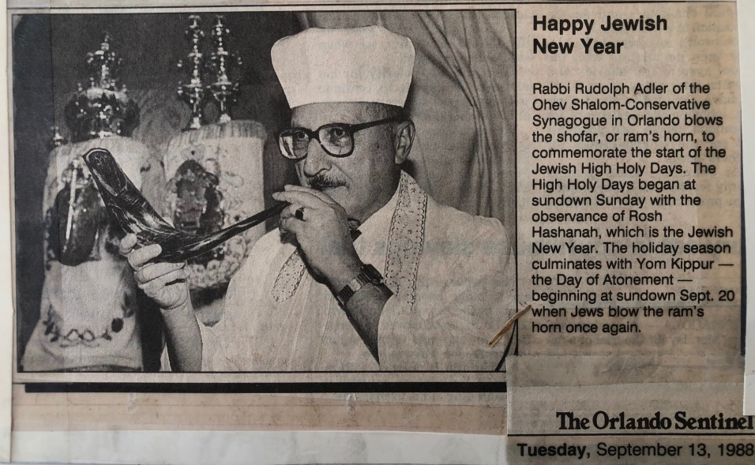

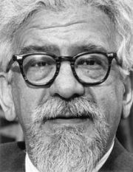

In the years following the Shabbaton , my father continued to communicate with Rabbi Heschel. Here is a letter from Rabbi Heschel regarding a book (Commentary of the Mishneh) that my father wrote on the Mishnah which Dad asked Rabbi Heschel to review.
My father saved his letter with his important papers. He donated the book to the Hebrew University of Jerusalem.
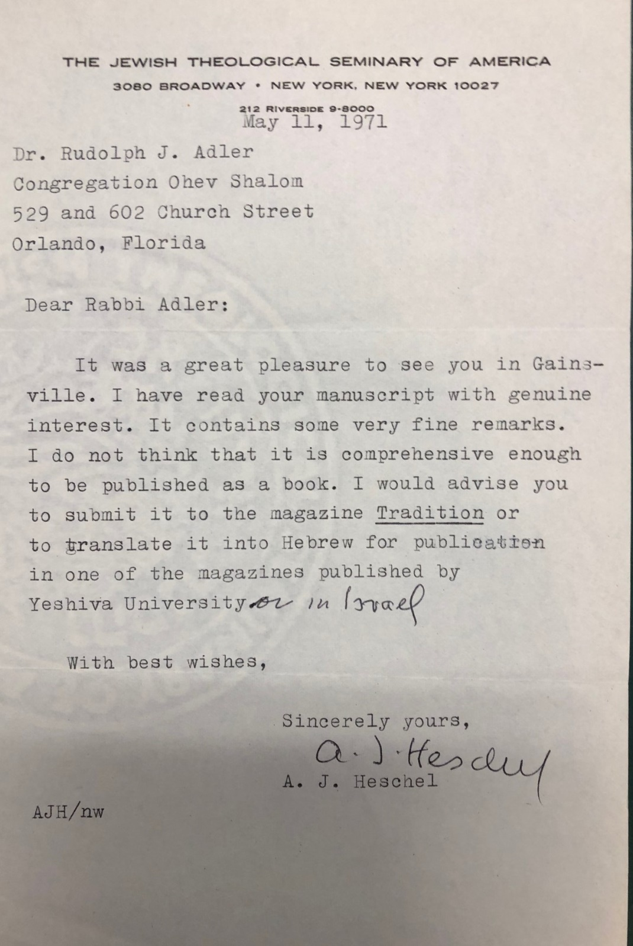
I would like to conclude with the prayer that sanctifies time:
Shehecheyanu: Blessed are You, Adonai our God, Sovereign of all, who has kept us alive, sustained us, and brought us to this season. (Time) 